P425/2
APPLIED MATHEMATICS
Paper 2
Jul/ Aug 2018
3 Hours


MUKONO EXAMINATIONS COUNCIL
Uganda Advanced Certificate of Education
APPLIED MATHEMATICS
Paper 2
3 Hours

INSTRUCTIONS TO CANDIDATES
Answer all the eight questions in section A and any five from section B
Any additional question(s) answered will not be marked.
All necessary working must be clearly shown.
Begin each answer on a fresh sheet of paper.
Silent, non – programmable scientific calculators and mathematical tables with a list of formulae may be used.
In numerical work, Take g = 9.8ms⁻²

SECTION A (40MARKS)
Attempt all questions
- A random variable X is normally distributed and is symmetrical about$x=25$. If$P\left(X≤20\right)=0.1750$, find$P(25≤X≤32)$. (5 marks)

- A stone is thrown from the edge of a cliff with a velocity of $50ms^{-1}$ at an angle of $\tan^{-1}\left(\frac{7}{24}\right)$ above the horizontal. The stone strikes the sea at a point 240m from the foot of the cliff. Find the,
- time for which the stone is in air.
- height of the cliff. (5 marks)

- Show that the equation $x^{3}+2x^{2}-4x-4=0$ has three roots in the interval $x=-3$ to$x=2$. Hence use linear interpolation once to find the positive root correct to one decimal place. (5 marks)

- The table below shows the amount of money in millions (A) given to some districts in Uganda for “Entandikwa” scheme.
A | 25 - <30 | 30 - <40 | 40 - <50 | 50 - <60 | 60 - <80
f | 4 | 10 | 4 | 3 | 5

Determine the mean and standard deviation of the money given out in the scheme. (5 marks)

- A string with one end fixed, passes under a movable pulley of mass 2kg, over a fixed pulley and carries a 5kg mass at its other end. If the system is released from rest, find the
- tension in the string.
- acceleration of the movable pulley. (5 marks)

- Study the flow chart below
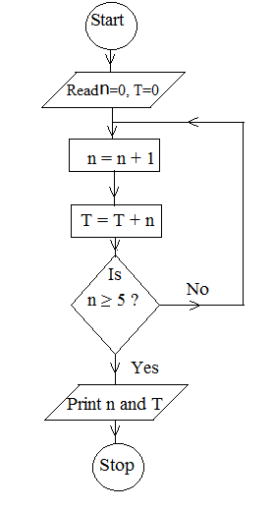
- Perform a dry run for the flow chart.
- State the purpose of the flow chart. (5 marks)

- An elastic string of natural length 60cm is stretched to 70cm by a stone of mass 1.5kg hanging on it. Find the,
- modulus of elasticity of the string.
- energy stored in the stretched string at equilibrium. (5 marks)

- The probability that Blessing goes for work using a taxi is $\frac{2}{3}$ and her probability of arriving early for work when she use a taxi is$\frac{3}{4}$. If she uses a private means, her chance of arriving late is$\frac{1}{3}$.
- What is the probability that that she arrives early for work on a given day.
- If she arrives early, what is the probability that she used a private mean?
(5 marks)

SECTION B (60 MARKS)
Attempt any five questions
- A continuous random variable R has a probability density function (pdf), f(r) shown graphically below
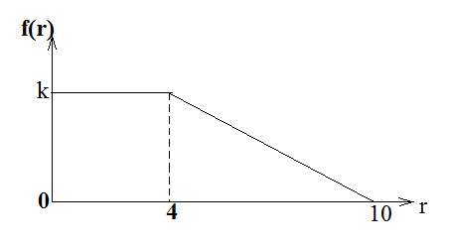
- Find the,
- value of k
- expression of the pdf, f(r)
- determine the distribution function (c.d.f) of R and sketch it.
- Calculate $P(3≤R<7)$ (12 marks)

- Two cars A and B are proceeding one on each road, towards the point of intersection of two roads which meet at an angle of 60⁰. If the speeds of A and B are $20kmh^{-1}$and $32kmh^{-1}$ and are 70m and 40m respectively from the cross road, and the cars maintain their speeds, determine the
- speed of B relative to A.
- time when they are nearest to each other.
- the distance of B from the cross road when they are nearest to each other. (12 marks)

- (a) Use the trapezium rule with equal width of $\frac{π}{6}$ to estimate
$\int_{0}^{\frac{2π}{3}}{\left(x-\sin{x}\right)}dx$. Give your answer correct to 3 decimal places.
(b) Determine the percentage error made in the estimation. (12 marks)

- The table below shows marks scored by 8 students in UNEB final examination mock examination.
UNEB | 79 | 67 | 52 | 71 | 97 | 55 | 41 | 86
Mock | 75 | 60 | 45 | 55 | 85 | 43 | 30 | 70

- (i) Draw a scatter diagram for the data.
(ii) On the same diagram draw a line of best fit.
(iii) Use the line of best fit to estimate the mark that a student who scored 68 in Mock will score in UNEB.
- Calculate the rank correlation coefficient for the marks in Mock and UNEB and comment on your result. (12 marks)

- (a) Forces of magnitude 4,1,2 and 3N act along sides AB, BC, CD and AD respectively of a
rectangle ABCD in which $AB=4m$ and $BC=3m$. Given that the direction of the forces
are indicated by the order of the letters, determine the,
- Magnitude of the resultant force.
- Length AT, where T is a point on AB where the line of action of the resultant force cuts AB.
(b) A non-uniform ladder AB of weight 78.4N and length 5m is freely suspended
horizontally by two light inelastic strings AC and BD that make angles of ${30}^{0}$and ${40}^{0}$
respectively with the upward vertical. Find the distance from A where the weight of
the ladder acts. (12 marks)

- (a) The height of the top of a ladder of length$l$ resting against a vertical wall making an angle of $θ^{0}$ with the horizontal is given by$h=l\sin{θ}$.
- Show that the maximum relative error made in estimating the height $h$ is given by$\left|\frac{∆l}{l}\right|+\left|\frac{∆θ}{\tan{θ}}\right|$ , where $∆l$ and $∆θ$ are the respective errors in $l$and $θ$.
- Find the maximum relative error in $h$ if $l$ and $θ$ are measured to be $3.96m$ and ${59}^{0}$ respectively.
(b) The length and width of a rectangle are measured as 4.5m and 2.4m with percentage
errors of 5% and 2% respectively.
Determine the,
- range within which its area lie.
- maximum possible error made in estimating its perimeter. (12 marks)

- (a) Mariam’s probabilities of passing Physics, Economics and Mathematics are
$0.6, 0.75, and 0.80$ respectively.
- Find the probability that she passes at least two subjects.
- If it is known that she passed at least two subjects, what is the probability that she failed Economics?
(b) At a certain fuel station, 30% of the customers buy Super (S), 60% buy Regular (R)
and the remainder Diesel (D). Of those who buy S, 25% fill their tank, 20% fill their
tank with D and 30% do not fill their tank with R.
- Find the probability that when a vehicle leaves the station, it has a full tank
- Given that a vehicle has full tank, what is the probability that the tank contains Diesel? (12 marks)

- (a) A car of mass 750kg is travelling along a horizontal road. If the resistance to the motion
total to 240N and the car’s engine is working at a constant rate of 12kW, find
- the acceleration of the car when travelling at velocity of $20ms^{-1}$.
- the maximum velocity of the car up a hill inclined at $\sin^{-1}\left(\frac{1}{25}\right)$ to the horizontal assuming the resistance remains constant.
(b) A brick of mass 0.8kg slides 6 metres down a plane inclined at $\sin^{-1}\left(\frac{3}{5}\right)$ to the
horizontal. If at the top of the plane, the brick is given an initial speed of $0.4ms^{-1}$, and
at the bottom it has speed of $5.4ms^{-1}$. Calculate
- work done against resistive force.
- Magnitude of the resistive force (12 marks)

END

